Ian Galler

Prof.

Advanced Web Development

20 November 2018

Milestone 4

The purpose of this milestone is to deploy a similar website to milestone 3, but add the option of viewing your searched content, or bookshelf content, in a list or grid view. The pagification was removed and replaced with a load more option. I added CSS to create a Fall like feel. Each item is placed in a white box so the background image does not intrude on the other objects.

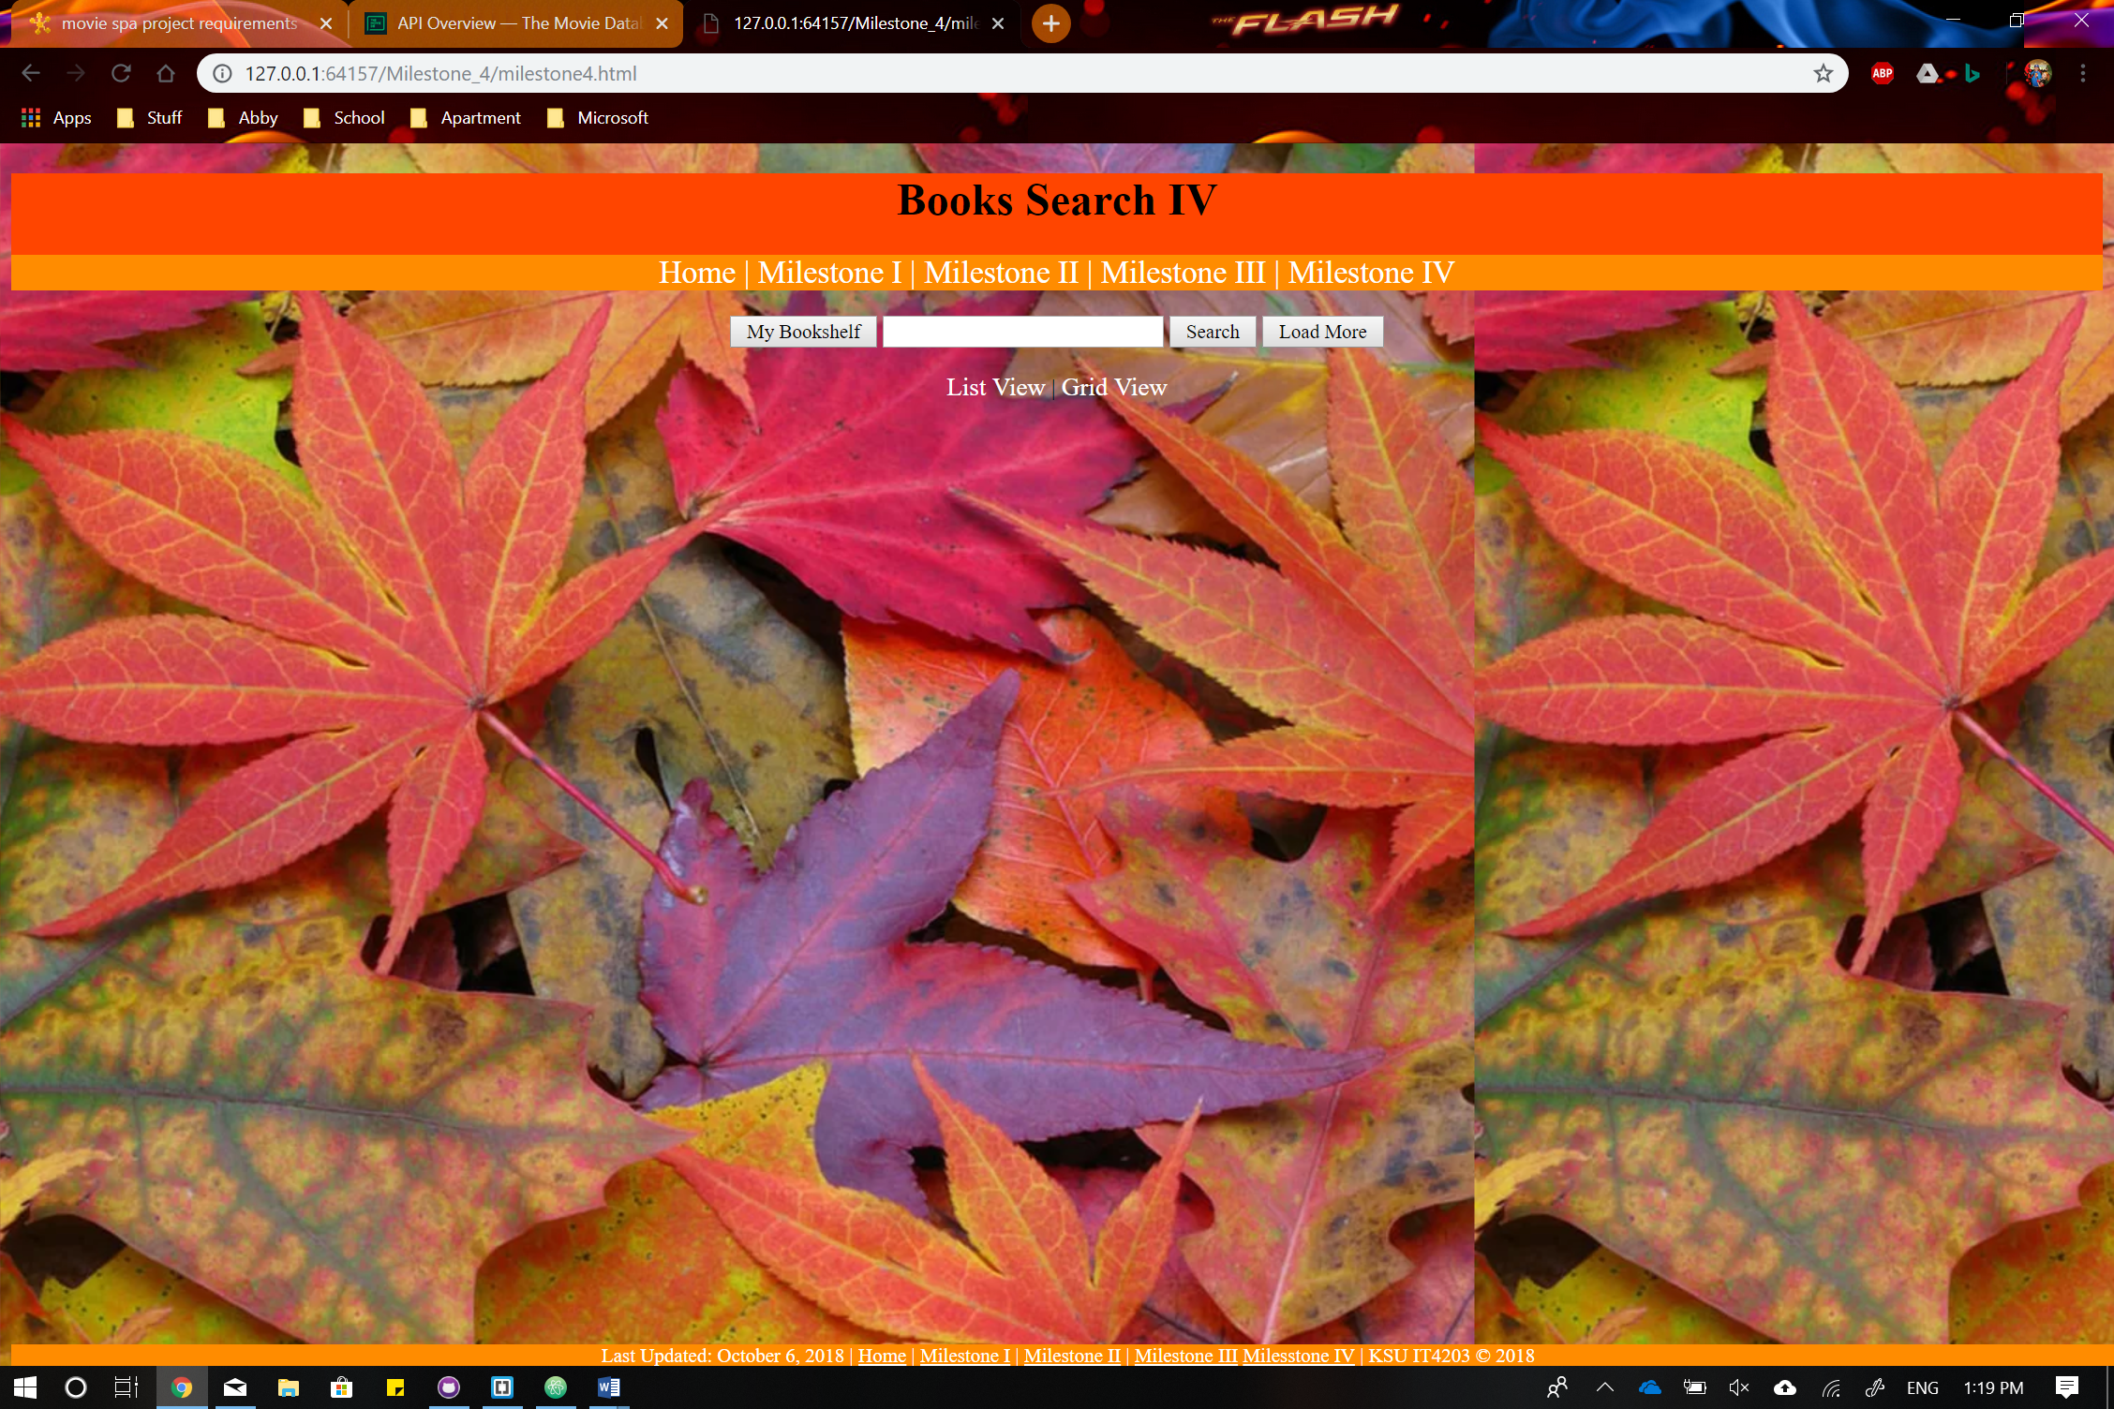

The following photo below shows the user’s/my book shelf when the specified button is clicked. The information is centered in the individual object boxes. The displayed info in general is not centered and I am not sure why it wont work for me to obtain said idea.

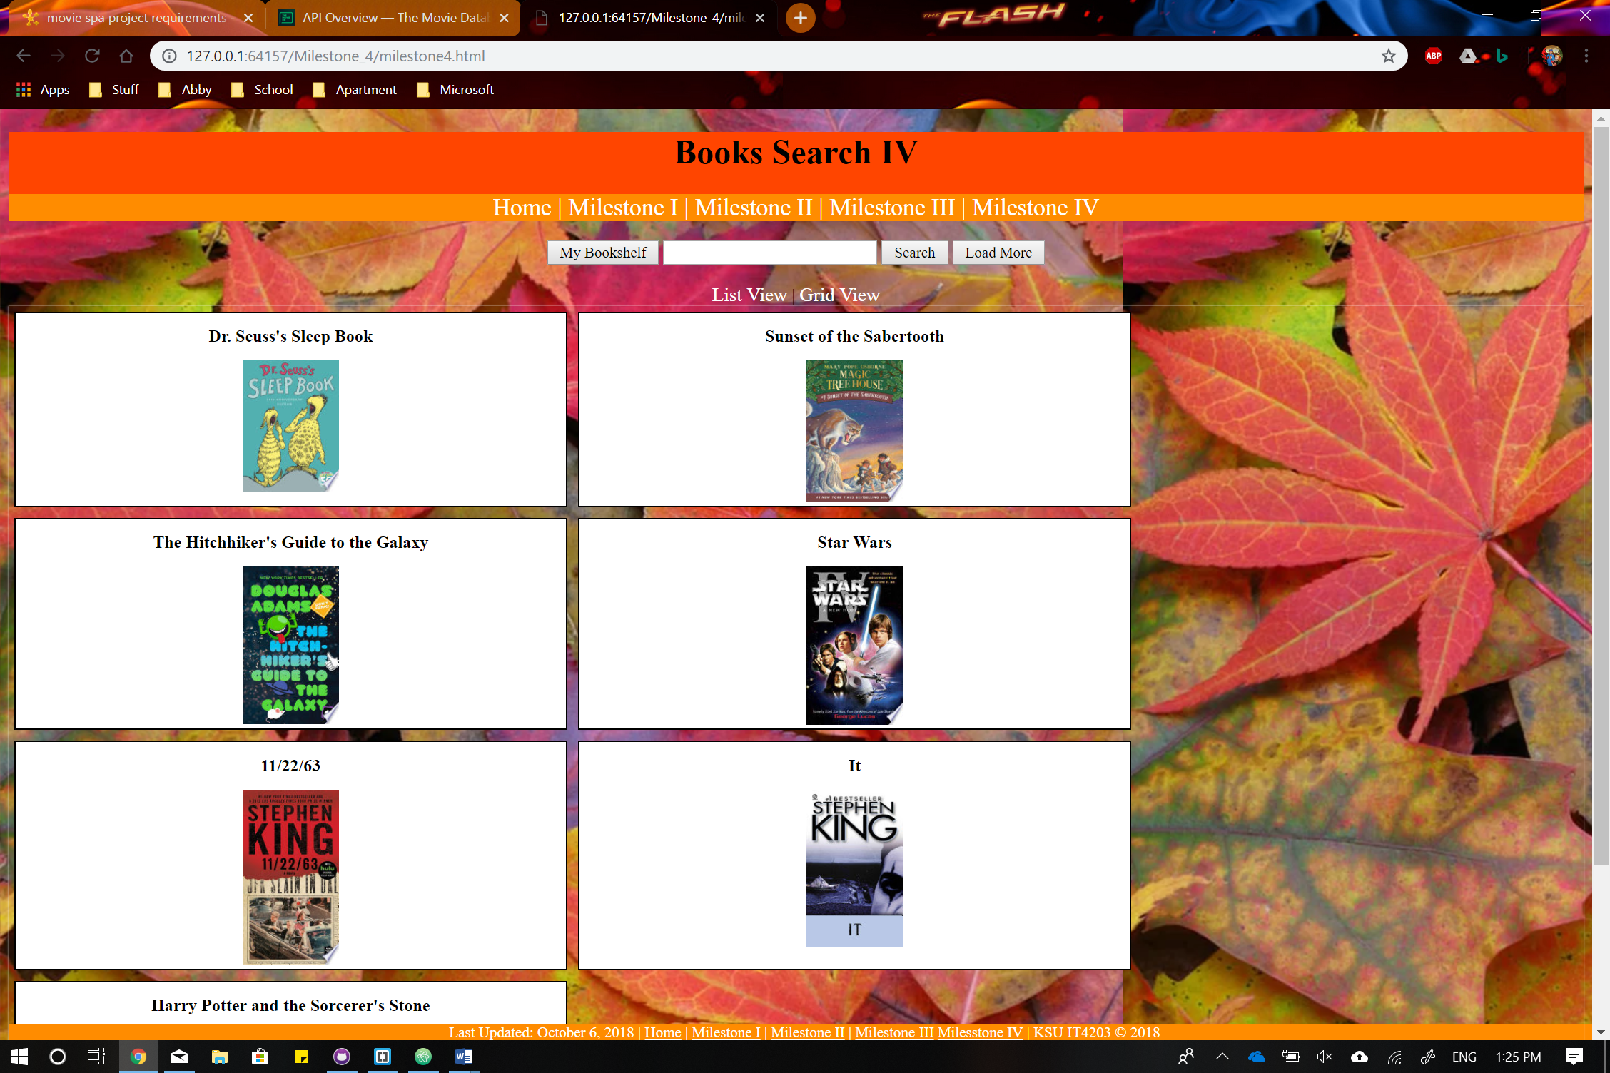

Below is a screenshot of the search results in a list view. The above screenshot of the bookshelf is in grid view. Both search and bookshelf can be switched between views as well. Because the information is all similar to milestone 3 the idea is pretty straightforward and isn’t needed to be explained further since it was done in the last module turned in.

